Carbon Footprint of Dormitory of Mahidol University, Salaya Campus, Thailand
Sayam Aroonsrimorakot
Faculty of Environment and Resource Studies, Mahidol University, Salaya campus, Nakhonpathom 73170 Thailand
sayamthai88@gmail.com
Chumporn Yuwaree
Faculty of Environment and Resource Studies, Mahidol University, Salaya campus, Nakhonpathom 73170 Thailand
chumporn.yuw@mahidol.ac.th
Chumlong Arunlertaree
Faculty of Environment and Resource Studies, Mahidol University, Salaya campus, Nakhonpathom 73170 Thailand
chumlong.aru@mahidol.ac.th
Rungjarus Hutajareorn
Faculty of Environment and Resource Studies, Mahidol University, Salaya campus, Nakhonpathom 73170 Thailand
rungjarat.hut@mahidol.ac.th
and Tarinee Buadit
Faculty of Environment and Resource Studies, Mahidol University, Salaya campus, Nakhonpathom 73170 Thailand
second_to_none117@hotmail.com

Abstract— Greenhouse gases (GHGs) emission, a significant amount of which comes from corporate organizations, is also the cause of global warming, and is a threat to humanity at this time. As a result, the concept of measuring GHGs by the management of organizations was established to help reduce these amounts. This study focuses on measuring the amount of GHGs or Carbon Footprint by calculating GHGs emissions in units of carbon dioxide equivalent (CO₂e) from the activities of the dormitories of Mahidol University in the year 2010 with data collection of GHGs sources such as electricity and water supply consumption, quantity of wastewater and garbage. Then, multiply these data by the internationally emission factors. The results showed that a GHGs emission from dormitories is equal to 1,270.49 tonCO₂e, it means that average GHG emission per head of student was 0.3317 tonCO₂e. Sources that emit the most GHGs are the use of electric energy, followed by produced solid waste. Thus, power consumption and the amount of waste created should be reduced with the use of current energy-saving technologies or energy saving campaigns to reduce the power consumption of students including waste classification to facilitate recycling and so on.
Keywords— Carbon Footprint, Dormitory, Greenhouse Gases
- I. INTRODUCTION
Carbon footprint for companies is to assess the greenhouse gas emissions resulting from their activities, both directly and indirectly, such as the burning of fuel, electricity consumption, and waste management and transport, by showing the amount of greenhouse gas emissions in units of carbon dioxide equivalent (CO₂e). Six species of greenhouse gas are used to assess the carbon footprint under the Kyoto Protocol; carbon dioxide (CO₂), methane (CH₄), nitrous oxide (N₂O), hydrofluoride perfluoro carbons (HFCs), perfluoro carbons (PFCs) and sulfur hexafluoride (SF₆).
Carbon footprint can be calculated by using the life cycle assessment (LCA), which is the international standard ISO 14040, 14044, used for the assessment of environmental impact throughout the life cycle. It can be calculated from the formula: CO₂ equivalent of each process = Amount of activity x CO₂ emission intensity. Total amount of every type of greenhouse gas from all activities, which were converted into units of carbon dioxide equivalents by multiply total emissions of each type of greenhouse gas with its global warming potential (GWP) , is the Carbon Footprint of the organization.

- II. METHODOLOGY
A. Setting Organization Boundaries
The dormitories of Mahidol University, Salaya campus, consist of 10 buildings are divided into 6 men's dormitories (No.3-4, 6-7, 8-9) and 4 female’s dormitories ( No.1-2,10,11). Dorm 1-9 is the same pattern as shown in Fig.1, while female’s dorm no.11 (new constructed in year 2006) is larger and accommodates more residents as shown in Fig.2.

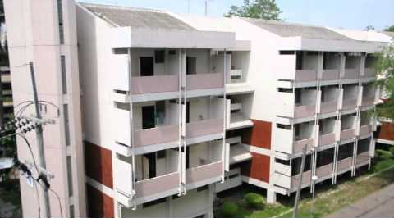
Fig. 1 Pattern of dorm no. 1-9
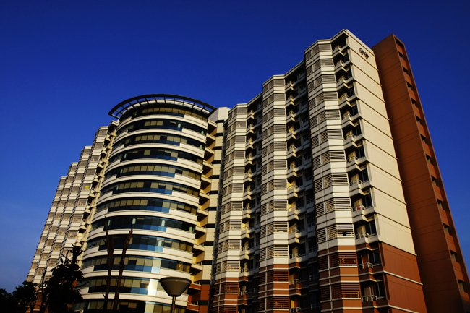

Fig. 2 Dorm no.11 (only female)

B. Setting Operational Boundaries
Identify all sources of GHGs emissions both direct and indirect sources, which can be divided into the 3 scopes as follows:
Scope 1: Amount of GHGs generates by sewage treatment processes.
Scope 2: Emissions arise from purchase of electricity and water supply.
Scope 3: Indirect GHGs emissions, such as waste generated.

C. Data Inventory
The data collected in this study were the collected relevant documents of both primary data (solid waste occurred) and secondary data (electricity and water supply, quantity and quality of the wastewater and number of students in each residence hall).
Solid waste arising, the researchers used random sampling to weighing and sorting type of waste (as shown in Fig.3) because each type of waste has a different emission factor that affect to the calculation of GHGs.


Fig.3 Random sampling to weighing and sorting type of solid waste
D. Calculation of GHG Emission
GHGs can be calculated by multiplying with the emission factor, which is commonly used internationally, and in accordance with the guidelines of the Intergovernmental Panel on Climate Change (IPCC) or from a national database of each country, and so on. The example of emission factors that are used in the study are shown in Table I.
Table I
THE EXAMPLE OF EMISSION FACTOR USED IN THE STUDY [1]
GHGs Sources | Unit | Emission Factor (kgCO₂e) | References
Water Supply | m³ | 0.0264 | Metropolitan Waterworks Authority (Thailand)
Electricity | kWh | 0.5610 | TC Common data

- II. RESULTS
Resource consumption and waste generated by the dormitories of Mahidol University, Salaya campus in the year 2010 are presented in Table II.

Table II
CONSUMPTION OF RESOURCES AND THE AMOUNT OF WASTE GENERATED

GHGs Sources | Resource consumption/  Waste generated
Scope 1
Quantity of wastewater | 157996.8 L
Scope 2
Tap water used | 197,496 m³
Electricity consumption | 1,800,551.5 kWh
Scope 3
Solid waste generated | 24,795.16 kg

The total GHGs emissions that resulted from the activities of the dormitories of Mahidol University, Salaya campus is equal to 1,270.49 tonCO₂e as shown in Figure 4.

Fig. 4 The amount of GHGs resulting from the activities of dormitories of Mahidol University, Salaya campus in the year 2010

The ratio of the amount of greenhouse gases generated of each activity is seen in Figure 5.

Fig. 5 Percentage of greenhouse gases emissions of each activity.
In summary, in 2010, the dormitories of Mahidol University, Salaya campus releases greenhouse gas emissions from activities in the amount of 1,270.49 tonCO₂e. The emission of greenhouse gases by the dormitories of Mahidol University, Salaya campus in each scope is demonstrated in Table III.

Table III
THE AMOUNT OF GREENHOUSE GASES THAT RESULT FROM THE ACTIVITIES OF DORMITORIE OF MAHIDOL UNIVERSITY
Greenhouse Gases Source | Total of GHGs Emissions (tonCO₂e)
Scope 1: Direct greenhouse gas emissions  - Greenhouse gases generated by the wastewater treatment | 45.29
Scope 2: GHGs emissions arising from the importation of energy  - Electricity consumption  - Water supply | 1,010.11  5.21
Scope 3: Indirect greenhouse gas emissions  - Solid waste generate | 209.87

Dormitory is the place where energy and water are consumed in high quantities because there are a lot of student lived and activities in daily life is continued including use of computer, fan and lamp for work and study, use of refrigerator and microwave for cooking, watch TV for relax, and high water consumption of dishwashers, washing, bathing and others.
Apart from the consumption of electricity and water resources in high volume, dormitory also generates waste in high volume as well both solid waste and wastewater (as shown in Fig.6), which are the source of greenhouse gases emissions. As a result, the dormitory is a one of most of greenhouse gas source in university compared to other buildings.
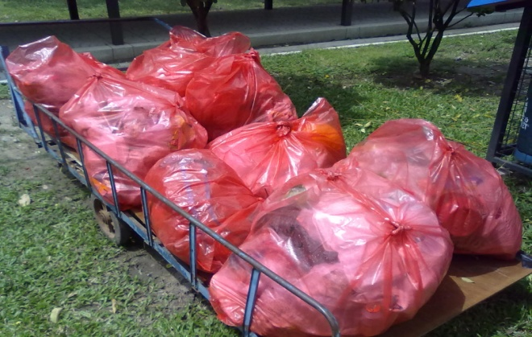
Fig.6 Amount of solid waste generate from each dormitory of Mahidol University per day

Alternatives to compensate for the GHGs emissions of the organization
- Planting trees to absorb CO₂
Teak plantations can produce carbon sequestration in the approximate amount of 4.61 tons/rai/year (1 rai = 1,600 SqMts). For Northern Black Wattle, the amount of carbon sequestration is about 9.08 tons/ha/year. As such, if the dormitories of Mahidol University, Salaya is to reduce the amount of carbon dioxide, it should plant 275.59 rai of teak or plant 139.92 rai of Northern black wattle.
- Carbon Credit (CERs)
It can be observed that through the three cooperative mechanisms of the Kyoto Protocol, carbon credits become more like commodities, and they are tradable or exchangeable in a market known as the “carbon market.” If the dormitories of Mahidol University, Salaya wants to reduce the amount of GHGs 1,270.49 tonCO₂e per year by purchasing CERs at the price of the ECX Dec '11 market, the dormitories will have to pay the total cost of 703,023.12 Baht or will pay a total cost of 704,677.30 Baht for the BlueNext Spot market. (Carbon credit trading market at 21-25 March 2011 from Thailand Greenhouse Gas Management Organization; TGO [3])

- III. CONCLUSIONS
- The total of the greenhouse gas emissions by the dormitories of Mahidol University is 1,270.49 tonCO₂e. The source of greenhouse gases that has the highest emissions is electricity consumption, followed by the solid waste generated. The source with the minimal release is the consumption of water supply.
- In addition, the study also shows that the release of greenhouse gases in semester period is over the vacation and GHGs emission from female’s dormitories are more than emission from male’s dormitories as shown in Table IV.

Table IV
COMPARISON OF THE AMOUNT OF GREENHOUSE GASES GENERATED DURING THE SEMESTER / VACATION.
Period | Dormitory (tonCO₂e)
Period | Female | Male
Semester | 132.37 | 58.22
Vacation | 11.09 | 8.19

- Number of students living in dormitories in year 2010 was a total of 3,830 people; it means that average GHG emission per head of student was 0.3317 tonCO₂e.
- The amount of greenhouse gas emissions is not only determined by the amount of resources used or the amount of waste that occurs. It also depends on the Emission Factor as well. Although the source amount may be less, if the source has a higher Emission Factor used to calculate the amount of greenhouse gas emissions, the results obtained may be much higher than a greater source with a lower Emission Factor. The time of the academic calendar is another factor that affects the amount of greenhouse gases. This is due to the fact that the in-class semester period and the vacation period have different levels and types of student and staff activity.
IV. CONSTRAINTS
- Wastewater quality data used to calculate the amount of greenhouse gas emissions is the data of year 2009 due to data limitations of monitoring wastewater quality of university.
- Amount of wastewater generated can not be correct because no measurement system. Therefore, this study calculates the amount wastewater from 80 percent of the amount of water used. Obtained values may have the error.
- REFERENCES
[1] Thailand Greenhouse Gas Management Organization. 2011. Emission Factor [Online]. Available at:http://thaicarbonlabel.tgo.or .th/ download/Emission_Factor.pdf. April 20, 2011.
[2] Intergovernmental Panel on Climate Change. 2007. 2006 IPCC Guidelines for National Greenhouse Gas Inventories: Volume 5 Waste, Chapter 6: Wastewater Treatment and Discharge. Available source: http:// www. ipcc-nggip.iges.or.jp/public/2006 gl/vol5. html. June 13, 2011.
[3] Thailand Greenhouse Gas Management Organization. 2011. Carbon Market [Online]. Available at: http://www.tgo.or.th/index.php? option=com_content&task=section&id=9&Itemid=50. May 10, 2011.
[4] Thailand Greenhouse Gas Management Organization. 2011. GHG & Climate Change [Online]. Available at: http:// www.tgo.or.th/ index.php?option=com_content&task=section&id=5&Itemid =28. Jauary 20, 2011.
[5] United Nations Framework Convention on Climate Change. 2011 . United Nations Framework Convention on Climate Change [Online]. Available at: http://unfccc.int/2860. php. January 20, 2011.

